**Portfolio (Week-5)**

In this week, we are creating a react application. For this we will first check that we have installed the node js to our pc. Then we will create a directory called “React work” in our week 5 folder for CN5006. We will give an npx command for that.

Once the myapp is created, we will move to the myapp directory by using the cd command and give the npm start command

We will run the given code that will provide us the following output:

Task 1:

Now, we will make some changes to the code to change the text in the output:

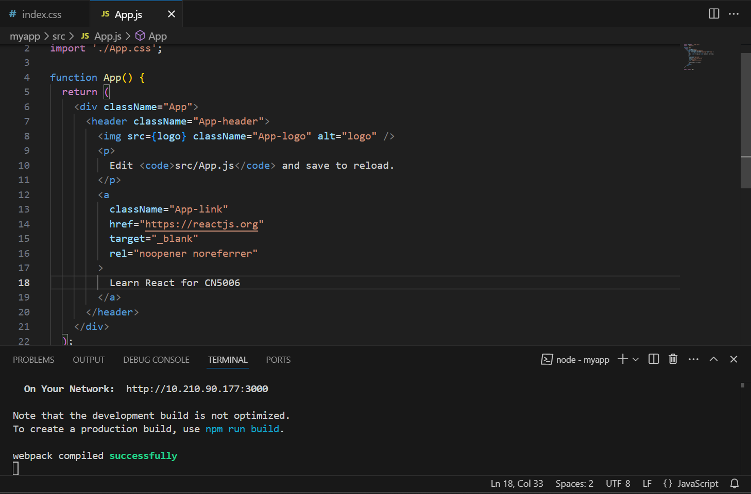 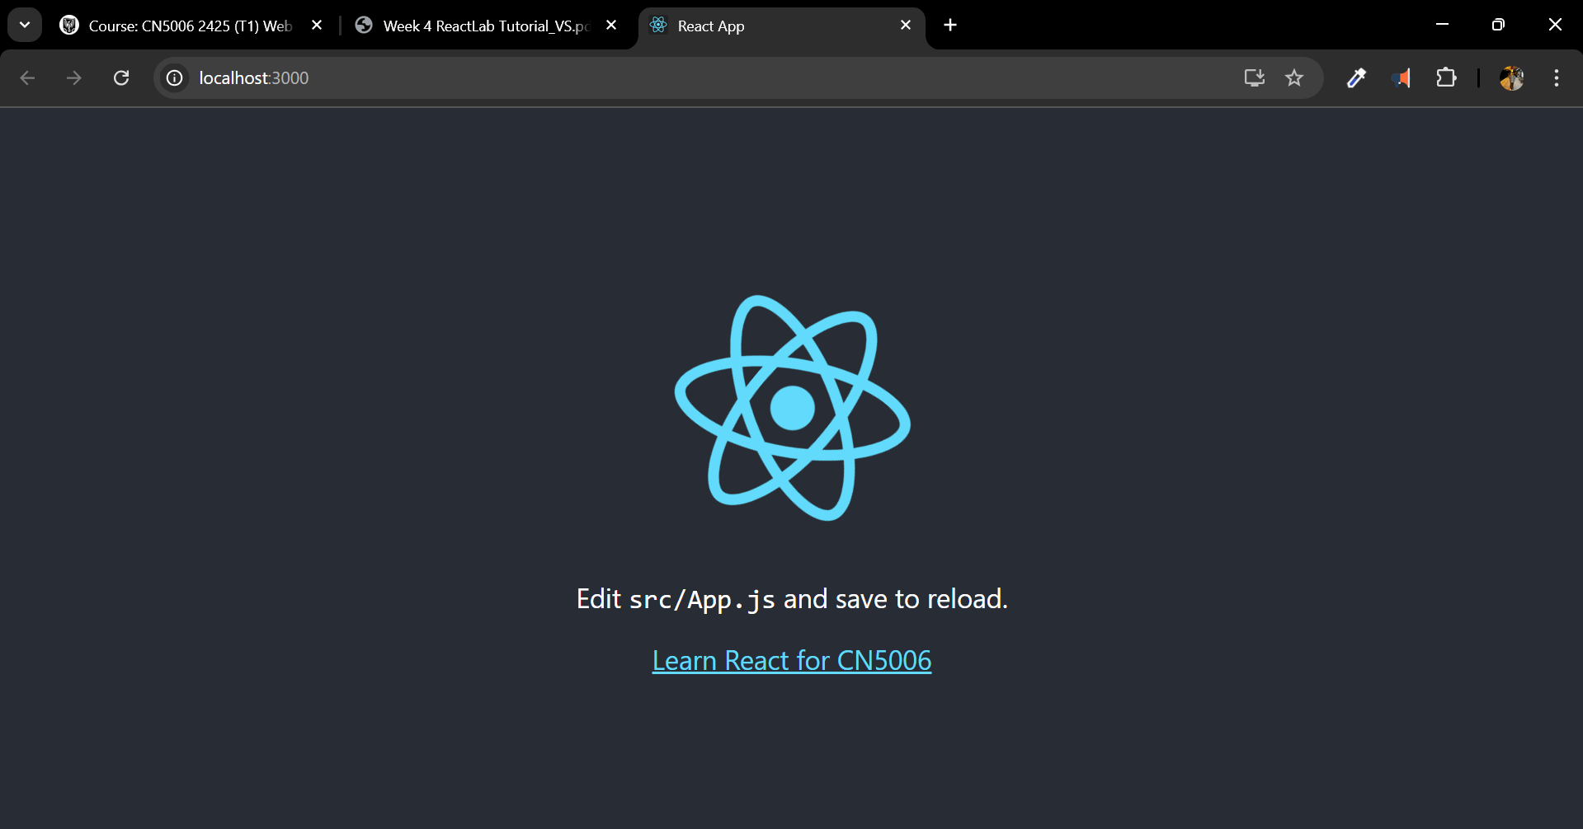

Task 2:

We will now change the background colour by changing the colour code in the css file of the app:

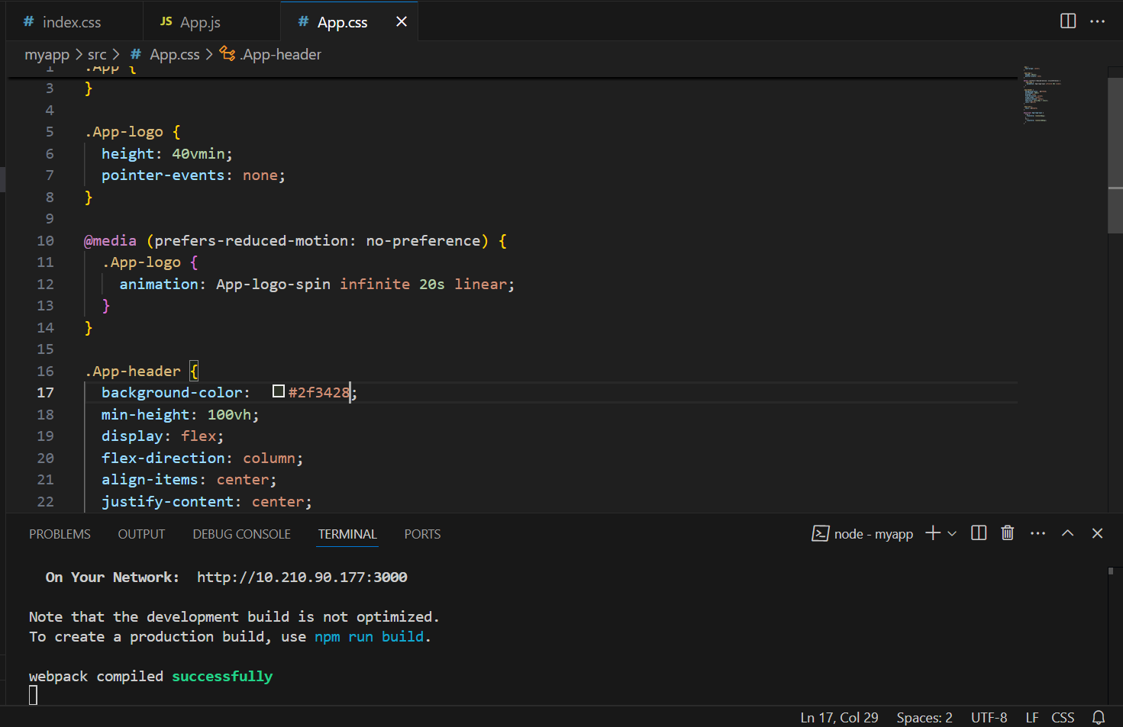

Task 3:

We will create a mygreetingapp for this task as instructed in the lab task file

Now we will import this file into the index with writing the import code into the index.js file:

Now we will remove the app tag from the index file as instructed in the tutorial file:

And we will write the GreetingElement tab instead:

And this is how our output looks like in the browser:

Task 4:

Now we will create a file named mygreetingprop.js and enter the code from this week lab guide file :

Similar to what we did with the above file, for this one as well, we will import the file to the index.js file and then create a tag for it :

It will provide us with this output:

Task 5:

To create greeting for the whole week, we will copy the greeting line for Monday and then change the name of the day in the copied lines to the suitable day like this:

and it fill give this output:

Task 6:

Now we will create a appbackgroundcolour file that will change the colour of the background:

Now we will import the file into the index file and then make the changes as we did in the previous tasks:

Now let’s jump on to the question and answer part:

1. What is React

Ans: React is open-source JavaScript library that is created by Facebook. It helps in building user interfaces, and it is especially used for single-page applications.

1. What do you understand by React component and what command do you use to create a React component with or without property

Ans: React component is reusable data that defines a part of user interface. When creating React component for with property we use “**function** MyComponent() { **return** Hello, World!; }” and for without property we use “**function** MyComponent(props) { **return** <h1>Hello, {props.name}</h1>; }”.

1. What command will you use to render the the newly created component named as MyReact?

Ans: ReactDOM.render(<MyReact />, document.getElementById('root'));

4. Suppose the MyReact Component has a property heading, write down the code that could be used to render the MYReact Component, and pass the message to the property heading as “this is my first element”

Ans: ReactDOM.render( <MyReact heading="this is my first element" />, document.getElementById('root') );

5. Observe this code and answer the questions below

6. <AppColor heading="This is first element" lbl ="Name :" color="green"/>

a. What is the name of the React Component

b. How many properties this component uses

Ans:

a) AppColor

b) Three: heading, lbl, and color

7. Look at the following Code: function GreetingElementwithProp(props) { return (

**Wellcome , {props.studentname}**

;

); } export default ??????

what will you write to make this export this function correctly? Hint you need to replace ?????? with the correct word.

Add a function that takes two properties as numbers ,add these numbers on the click event of the button and display the sum. Hint you will be using in jsx

Ans: To export default: **export** **default** GreetingElementwithProp;

To a function that takes two properties as numbers:

**function** AddNumbers(props) { **const** [sum, setSum] = React.useState(0);

**function** handleClick() { setSum(props.num1 + props.num2); }

**return** ( <div> <button onClick={handleClick}>Add Numbers</button> <p>Sum: {sum}</p> </div> ); }

To add these numbers on the click event of the button and display the sum:

<AddNumbers num1={5} num2={3} />